Setup Terraform for GCP Deployments.

# Overview

This document shows how to setup terraform, configure the Google provider for terraform (so resources may be deployed to GCP), deploy a test resource and then destroy it.

Using Terraform on Windows involves downloading the binary and running it from a CLI, such as the Windows command prompt or git bash. The binary can be used straight up if it or a symlink to is within the current working directory, though it is much easier to use if the directory containing the executable is added to PATH for the user or system.

The Google provider for Terraform uses the gcloud CLI to interact with GCP and deploy resources. This too will require installation. Once authentication is completed through the gcloud cli Terraform can be used to deploy resources to GCP.

# Terraform Installation (windows)

Download the terraform executable (zipped) from the Hashicorp Terraform download page. Unzip it to a directory and make a note of this directory. I put the contents into C:\terraform

* Hashicorp Terraform download page <https://developer.hashicorp.com/terraform/install?product_intent=terraform>

Add terraform to path for user by going to Edit environment variables for your account.

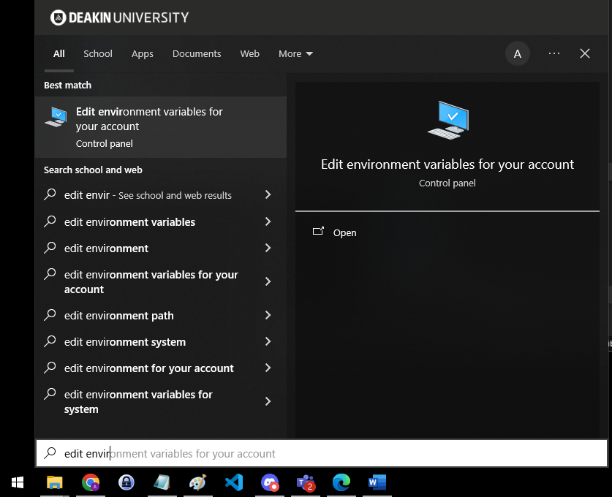

Edit Path and add an item. Add the directory containing the terraform executable.

Click OK and a coupe of times to exit editing environment variables.

Terraform CLI should now be available to run within a command prompt.

Confirm Terraform CLI works as expected by going to a command prompt, typing terraform and pressing enter. As no further commands were defined Terraform should show information about using it.

# Gcloud CLI installation (Windows)

Download the gcloud cli installer for Windows. Instructions for installation are available on the download page.

* Google gcloud CLI download page <https://cloud.google.com/sdk/docs/install>

Run through the installer following the prompts.

Once the installer has completed running open a command prompt and run:

gcloud auth application-default login

The above line will either open your browser or provide a link to open. Follow the prompts to authenticate with Google.

Once done Terraform will be authenticated and can now be ran.

# First GCP Deployment Using Terraform

Create a new folder and within it create a file named “example.tf”. To it add the following code.

provider "google" {

  project = "sit-23t1-project-echo-25288b9" *# replace with your project name if different*

  region  = "australia-southeast2"

  zone    = "australia-southeast2-a"

}

resource "google_compute_network" "vpc_network" {

  name                    = "terraform-network"

  auto_create_subnetworks = "true"

}

resource "google_compute_instance" "vm_instance" {

  name         = "terraform-instance"

  machine_type = "e2-micro"

  boot_disk {

    initialize_params {

      image = "debian-cloud/debian-11"

    }

  }

  network_interface {

*# A default network is created for all GCP projects*

    network =  google_compute_network.vpc_network.id

    access_config {

    }

  }

}

The code defines resources to create a VPC and a Compute Engine Virtual Machine within it. The provider specifies our project within GCP.

Perform the following commands in order:

* terraform init
  + This initialises terraform for the directory including downloading the Google provider executable.
* terraform plan
  + This will take actions to plan the deployment of the resources to GCP and it will provide output showing what it creates.
* terraform apply
  + This is the command to deploy the resources to GCP. It will ask for confirmation of yes to be input before deployment occurs.
* terraform apply -destroy
  + This command will clean up/destroy the resources that were deployed. It too will ask for confirmation to continue.

## Examples

init

plan

apply

apply -destroy

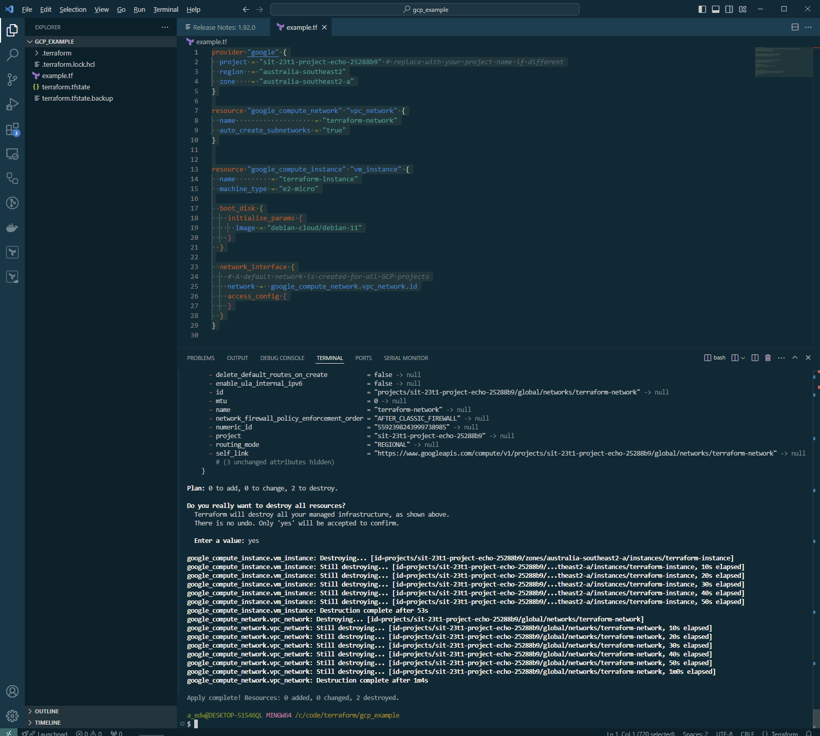

# Summary of Installation Steps (the TLDR)

* Download terraform executable and add to PATH
* Download gcloud cli and run gcloud auth application-default login
* Terraform is setup. Create some terraform code and run it to test.

# Reference Links

<https://developer.hashicorp.com/terraform/install?product_intent=terraform>

<https://registry.terraform.io/providers/hashicorp/google/latest/docs/guides/getting_started>

<https://cloud.google.com/sdk/docs/install>